- Copyright for test papers and marking guides remains with West Australian Test Papers.
- The papers may only be reproduced within the purchasing school according to the advertised conditions of sale.
- Test papers must be withdrawn after use and stored securely in the school until 2nd December.

CHEMISTRY
UNITS 1 & 2
2022

MARKING GUIDE

TIME ALLOWED FOR THIS PAPER

Reading time before commencing work: Ten minutes
Working time for the paper: Two hours, thirty minutes

MATERIALS REQUIRED/RECOMMENDED FOR THIS PAPER

To be provided by the supervisor:
This Question/Answer Booklet
Multiple-choice Answer Sheet
Chemistry Data Book

To be provided by the candidate:
Standard items: pens, pencils, eraser or correction fluid, ruler, highlighter.

Special items: calculators satisfying the conditions set by the SCSA for this subject.

IMPORTANT NOTE TO CANDIDATES
No other items may be taken into the examination room. It is your responsibility to ensure that you do not have any unauthorised notes or other items of a non-personal nature in the examination room. If you have any unauthorised material with you, hand it to the supervisor before reading any further.

Structure of this paper

Section | Number of questions available | Number of questions to be answered | Suggested working time  (minutes) | Marks available | Percentage of exam
Section One  Multiple-choice | 20 | 20 | 40 | 20 | 25
Section Two  Short answer | 9 | 9 | 50 | 66 | 35
Section Three  Extended answer | 5 | 5 | 60 | 77 | 40
 |  |  |  | Total | 100

Section One: Multiple-choice 25% (20 marks)

1 | a □ b □ c ■ d □ |  | 6 | a ■ b □ c □ d □
2 | a □ b ■ c □ d □ |  | 7 | a □ b □ c ■ d □
3 | a □ b □ c ■ d □ |  | 8 | a □ b □ c ■ d □
4 | a □ b □ c ■ d □ |  | 9 | a □ b □ c □ d ■
5 | a □ b □ c □ d ■ |  | 10 | a □ b □ c ■ d □

11 | a ■ b □ c □ d □ |  | 16 | a □ b □ c □ d ■
12 | a □ b ■ c □ d □ |  | 17 | a □ b □ c ■ d □
13 | a ■ b □ c □ d □ |  | 18 | a □ b ■ c □ d □
14 | a □ b ■ c □ d □ |  | 19 | a ■ b □ c □ d □
15 | a □ b □ c ■ d □ |  | 20 | a □ b ■ c □ d □

Section Two: Short answer 35% (66 marks)

Question 21 (7 marks)

(a) Calculate the relative atomic mass of this element, and thus state its identity. (2 marks)

Description | Marks
Ar = (78.99 x 24 + 10 x 25 + 11.01 x 26) / 100  = 24.32 | 1
Magnesium | 1
Total | 2

(b) Complete the table above. (4 marks)
Description | Marks
Species | Number of protons | Number of neutrons | Electron configuration | Mass number | Overall charge
W | 11 | 13 | 2, 8, 1 | 24 | 0
X | 12 | 14 | 2, 8 | 26 | +2
Y | 24 | 26 | 2, 8, 12, 2 | 50 | 0
Z | 17 | 20 | 2, 8, 8 | 37 | -1

Correct values for Species W | 1
Correct values for Species X | 1
Correct values for Species Y | 1
Correct values for Species Z | 1
Total | 4

(c) Which of the species in the table represents particles of the same element that was analysed by mass spectrometry in part a? (1 mark)

Description | Marks
Species X | 1
Total | 1

Question 22 (7 marks)

Complete the following table by;

- drawing a Lewis structure diagram for each compound, representing all electron pairs as either : or –, and
- predicting whether, when mixed with water, the compound would form a solution capable of conducting electricity.

Description | Marks
 | Lewis structure | Electrical conductivity in aqueous solution  (‘yes’ or ‘no’)
SeCl₂ |  | no
HNO₃ |  | yes
AlPO₄ |  | no

Correct structure for SeCl₂ | 1
Correct structure for HNO₃ | 1
Correct electron arrangement for AlPO₄ | 1
Square brackets and charges shown for AlPO₄ | 1
Correct electrical conductivities | 3
Total | 7

Also accept phosphate with 1 double bond and 3 single bonds

Question 23 (7 marks)

(a) State the function of a catalytic converter. (1 mark)

Description | Marks
To (catalyse reactions which) reduce the amount of harmful gases (e.g. carbon monoxide, unburnt petrol and nitrogen oxides) emitted by a vehicle. | 1
Total | 1

(b) Explain why the use of nanoparticles has greatly reduced the amount of precious metals used to construct a catalytic converter. (3 marks)

Description | Marks
Nanoparticles have a very large surface area (to mass ratio). | 1
This increases the frequency of collisions between the catalyst and the gases. | 1
Therefore less material is required (compared to the bulk) to provide an equivalent surface area / to function effectively. | 1
Total | 3

(c) Calculate the number of palladium atoms you could purchase for $1. (3 marks)

Description | Marks
m(Pd for $1) = 1 / 110  = 9.091 x 10⁻³ g | 1
n(Pd) = 0.00909 / 106.4  = 8.544 x 10⁻⁵ mol | 1
N(Pd) = 8.544 x 10⁻⁵ x 6.022 x 10²³  = 5.15 x 10¹⁹ atoms | 1
Total | 3

Question 24 (9 marks)

(a) Explain, in terms of intermolecular forces, why the vapour pressure of hexane is much higher than the other two liquids. (3 marks)

Description | Marks
Hexane is non-polar and exhibits only dispersion forces. | 1
Water and ethanol exhibit strong hydrogen bonds (in addition to dipole-dipole and dispersion forces). | 1
Thus the sum of intermolecular forces is lower in hexane, allowing vapour to form/evaporation to occur/molecules to escape the liquid more easily. | 1
Total | 3

(b) Which of these liquids has the highest boiling point? Justify your answer. (3 marks)

Description | Marks
Water | 1
Either of the following justifications:  - Boiling occurs when the vapour pressure equals the atmospheric pressure,  - thus a lower vapour pressure indicates a larger amount of heat is required before boiling will occur.  or  - A lower vapour pressure indicates stronger intermolecular forces are present,  - therefore a larger amount of heat is required to disrupt the bonding. | 2
Total | 3

(c) Explain, in terms of the kinetic theory, why the vapour pressure of water increases with increasing temperature. (3 marks)

Description | Marks
An increase in temperature increases the average kinetic energy of the particles. | 1
This would increase the rate of evaporation.  or  This would allow a higher proportion of molecules to evaporate. | 1
Resulting in increased collisions between the vapour and the container. | 1
Total | 3

Question 25 (9 marks)

(a) Which acidulant is likely to be the most polar? Justify your answer, making reference to the role of intermolecular forces. (4 marks)

Description | Marks
Oxalic acid | 1
The mobile phase is polar. | 1
Therefore components with highest polarity will dissolve more readily in the mobile phase. | 1
Thus (they will move more quickly through the column) resulting in a lower retention time. | 1
Total | 4

(b) State the likely effect on retention time if a lower temperature had been used. (1 mark)

Description | Marks
Longer / greater retention times | 1
Total | 1

(c) Describe how HPLC can be used to get quantitative information about the concentration of chemicals in the sample. (1 mark)

Description | Marks
The area under the curve can be used | 1
Total | 1

(d) On the grid below, sketch the expected chromatogram for the white wine sample. Label both axes appropriately. (3 marks)

Description | Marks
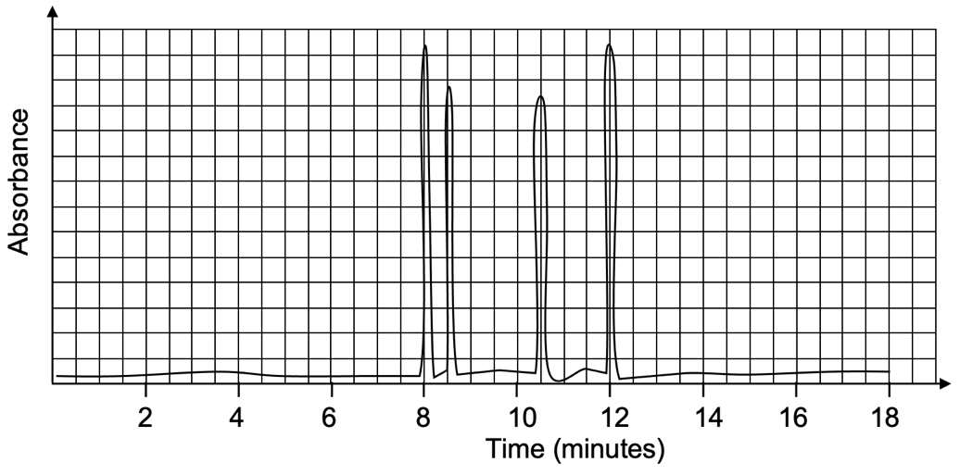

Correct y-axis label | 1
Correct x-axis label and scale | 1
Four peaks shown at correct retention times (i.e. 8, 8.5, 10.5, 12 min) | 1
Total | 3
Note: peaks may be any height and width, as long as retention times are accurate

Question 26 (8 marks)

Consider the three organic reactions which are partially summarised in the table below.

Complete this table by;
- drawing the structural formula for any missing organic reactants and products, and
- stating the IUPAC name for any missing organic reactants and products.

Description | Marks
Reactant shaken with bromine water, Br₂(aq)
 | 2
1,2-dibromo-2-ethylbutane | 1
Reactant shaken with chlorine water, Cl₂(aq), in the presence of UV light
 | 2
3-methylhexane | 1
Reactant shaken with iodine water, I₂(aq), in the presence of AlI₃(s)
 | 2
Total | 8
Note:
- one mark may be allocated for structural formulae, in the case of a minor error, such as a missing H atom
- follow through marks may be awarded if the IUPAC name correctly matches an incorrectly drawn structure

Question 27 (4 marks)

(a) Define a ‘supersaturated’ solution. (1 mark)

Description | Marks
A greater amount of solute than maximum has been dissolved in a solvent (at a given temperature).  or  The concentration of a solution is greater than that predicted using solubility data/tables. | 1
Total | 1

(b) Calculate the mass of KNO₃(s) crystals that would form. Show all workings. (3 marks)

Description | Marks
Maximum amount of KNO₃ dissolved in 100 g at 30 °C = 45 g | 1
Therefore maximum amount KNO₃ dissolved in 210 g at 30 °C = 94.5 g | 1
Mass of KNO₃ crystals that would form = 125 – 94.5 = 30.5 g | 1
Total | 3

Question 28 (8 marks)

(a) Describe how the student could use these indicators to identify which liquid was in each beaker. (2 marks)

Description | Marks
Add methyl orange indicator to a sample of each, the solution that turns red is HNO₃. | 1
Add phenolphthalein to a sample of the remaining two solutions, the pink one is KOH / the colourless one is water. | 1
Total | 2
Note: these tests may be performed in a different order or a slightly different method may be used; award one mark each time an observation based on indicator colour is clearly linked to the identity of a solution

(b) Complete this table, by including the distinguishing observation for test tube C. (1 mark)

Description |  | Marks
Test tube C | Pungent colourless gas formed | 1
Total |  | 1

(c) Write a balanced ionic equation for the reaction occurring in test tube C. (2 marks)

Description | Marks
NH₄Cl(s) + OH⁻(aq) → H₂O(l) + NH₃(g) + Cl⁻(aq)
Correct species | 1
Correct balancing | 1
Total | 2
Note: state symbols are not required for full marks.

(d) Complete this table, by including the distinguishing observation for test tube A. (1 mark)

Description |  | Marks
Test tube A | Colourless (odourless) gas formed | 1
Total |  | 1

(e) Write a balanced net-ionic equation for the reaction occurring in test tube A. (2 marks)

Description | Marks
MgCO₃(s) + 2 H⁺(aq) → H₂O(l) + CO₂(g) + Mg²⁺(aq)
Correct species | 1
Correct balancing | 1
Total | 2
Note: state symbols are not required for full marks.

Question 29 (7 marks)

(a) Calculate the amount of energy that would be released in the combustion of one full tank of petrol. (3 marks)

Description | Marks
m(C₈H₁₈) = 48.18 x 10³  = 48180 g | 1
n(C₈H₁₈) = 48180 / 114.224  = 421.803 mol | 1
E(released) = 421.803 / 2 x 10920  = 2303043 kJ  = 2.303 x 10⁶ kJ | 1
Total | 3

(b) Calculate the volume of hydrogen gas, stored at STP, that would be required to produce this same amount of energy. (2 marks)

Description | Marks
n(H₂) = 2303043 / 564 x 2  = 8166.82 mol | 1
V(H₂) = 22.71 x 8166.82  = 185468 L  = 1.855 x 10⁵ L | 1
Total | 2
Note: follow through marks may be awarded if correct calculation method is shown based on an incorrect value in part (a)

(c) Identify one (1) advantage and one (1) disadvantage of hydrogen powered vehicles. (2 marks)

Description | Marks
Many possible advantages, including;  - water is the only product  - carbon emissions are reduced  - CO₂(g) is not produced  - greater sustainability  - greener alternative | 1
Many possible disadvantages, including;  - very large storage capacity required  - storage and transport of H₂(g) for cars is not yet practical  - most H₂(g) is currently produced using fossil fuels  - this technology is expensive / buying a new car is expensive  - this technology requires further development / is not currently available | 1
Total | 2

Section Three: Extended answer 40% (77 marks)

Question 30 (10 marks)

(a) Calculate the percentage by mass of iron in jarosite, and suggest a reason for the different shade of red produced by this mineral. (3 marks)

Description | Marks
M(jarosite) = 500.818 | 1
% Fe = (3 x 55.85) / 500.818 x 100  = 33.46% | 1
Different shade may be due to a much lower percentage of iron. | 1
Total | 3

(b) Calculate the volume of CO₂(g), measured at STP, that would be produced, if all the huntite underwent decomposition. State your answer to the appropriate number of significant figures. (6 marks)

Description | Marks
m(Mg₃Ca(CO₃)₄) = 3.82 / 100 x 5.75  = 0.21965 kg | 1
m(Mg₃Ca(CO₃)₄) = 0.21965 x 10³  = 219.65 g | 1
n(Mg₃Ca(CO₃)₄) = 219.65 / 353.05  = 0.62215 mol | 1
n(CO₂) = 4 x 0.62215  = 2.4886 mol | 1
V(CO₂) = 22.71 x 2.4886  = 56.516 L | 1
= 56.5 L (3 SF) | 1
Total | 6

(c) Calculate the quantity of heat that would have been absorbed. (1 mark)

Description | Marks
E(released) = 0.62215 x 350  = 218 kJ | 1
Total | 1
Note: follow through marks may be awarded if correct calculation method is shown based on an incorrect value from part c)

Question 31 (17 marks)

(a) Identify the molecular shape of each of the following groups of hydrides. (3 marks)

Description |  | Marks
Group 15 hydrides | pyramidal | 1
Group 16 hydrides | v-shaped / bent | 1
Group 17 hydrides | linear | 1
Total |  | 3

(b) State and explain the trend in electronegativity as you move down the Group 17 elements. (3 marks)

Description | Marks
The electronegativity decreases. | 1
Moving down a group, the valence shell is further from the nucleus (and experiences increased shielding). | 1
Therefore a lesser force is exerted by the nucleus on a (bonding pair of) electron(s). | 1
Total | 3

(c) Explain, using the concept of electronegativity, which of the Group 17 hydrides is the most polar. (2 marks)

Description | Marks
HF is the most polar | 1
Hydrogen and fluorine have the largest difference in electronegativity.  or  Since fluorine has the highest electronegativity, the shared electron pair in HF is more strongly attracted to the F atom (compared with the other group 17 hydrides). | 1
Total | 2

(d) Identify the hydride which exhibits the strongest dispersion forces, and explain why this occurs. (3 marks)

Description | Marks
H₂Te | 1
H₂Te has the largest molecular mass / greatest number of molecular electrons. | 1
This results in;  an increased likelihood that a temporary dipole will form.  or  an increased likelihood that a stronger temporary dipole will form. | 1
Total | 3

(e) Plot this boiling point data on the graph on the previous page. (1 mark)

Description | Marks
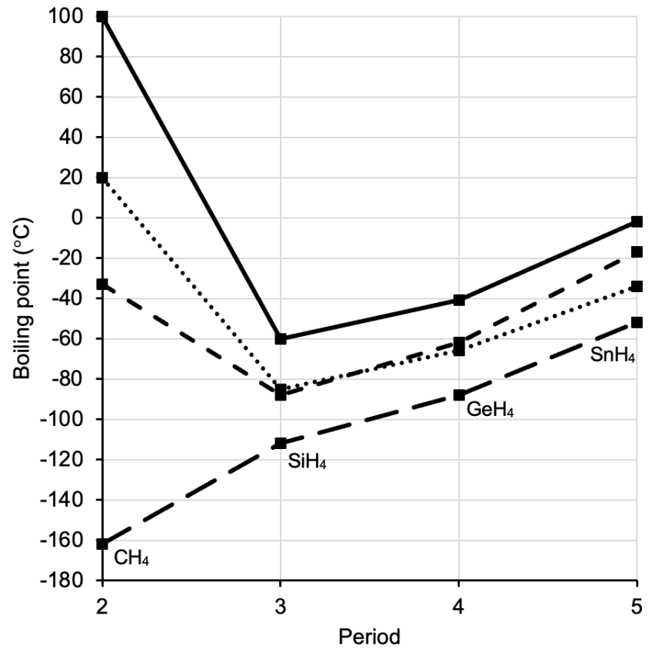

Points plotted correctly and joined by straight lines | 1
Total | 1

(f) Explain why the boiling points of H₂O, HF and NH₃ do not follow the same trend seen in the Group 14 hydrides. Support your answer with a diagram illustrating the predominant type of intermolecular interaction in NH₃. (5 marks)

Description | Marks
The Group 14 hydrides exhibit only dispersion forces. | 1
Whereas H₂O, HF and NH₃ all exhibit hydrogen bonding (in addition to dipole-dipole and dispersion forces). | 1
Thus these compounds have a greater sum of intermolecular forces (and therefore higher boiling point). | 1
Two molecules of NH₃ correctly shown | 1
Hydrogen bond shown between a H atom of one molecule and the non-bonding electron pair of another | 1
Total | 5

Question 32 (19 marks)

(a) Write a balanced net-ionic equation for this chemical reaction. (1 mark)

Description | Marks
2 HCO₃⁻(aq) + Ca²⁺(aq) → CaCO₃(s) + H₂O(l) + CO₂(g) | 1
Total | 1
Note: state symbols are not required for full marks.

(b) Define activation energy, and suggest what assumption can be made regarding the magnitude of the activation energy for this reaction. (2 marks)

Description | Marks
The minimum energy required for a collision to be successful. | 1
Low activation energy (since it occurs rapidly at room temperature). | 1
Total | 2

(c) On the axes below, sketch an energy profile diagram for this reaction. Label the axes, activation energy and enthalpy change. (4 marks)

Description | Marks
Enthalpy
Progress of reaction
E_{a}
ΔH

Axes labelled correctly | 1
Exothermic shape shown | 1
Activation energy labelled correctly | 1
Enthalpy change labelled correctly | 1
Total | 4

(d) Suggest two (2) ways that the rate of this reaction could be measured. (2 marks)

Description |  | Marks
1. | Measure the amount of CaCO₃ solid formed in a given time period / Measure how long it takes for an ‘X’ placed under the reaction vessel to be obscured | 1
2. | Measure the amount of CO₂ gas formed in a given time period | 1
Total |  | 2

(e) List two (2) variables that should be controlled in order to ensure the data collected by the student is valid. (2 marks)

Description | Marks
Any two (2) of the following;  - volume of NaHCO₃  - volume of CaCl₂  - concentration of NaHCO₃  - concentration of CaCl₂  - size of beaker / reaction vessel used  - whether the reaction mixture is stirred / swirled / left untouched etc | 2
Total | 2

(f) Predict the likely outcome of this investigation, using collision theory to support your answer. (4 marks)

Description | Marks
An increase in temperature will increase the reaction rate. | 1
Increased temperature increases the average kinetic energy of particles. | 1
This results in both an increased frequency of collisions, and | 1
an increased proportion of successful collisions / increased proportion of particles with E_{k} > E_{a}. | 1
Total | 4

(g) Explain why the final indicator colour was yellow, using chemical equations to support your answer. (4 marks)

Description | Marks
CO₂(g) + H₂O(l) ⇌ H₂CO₃(aq) | 1
H₂CO₃(aq) ⇌ H⁺(aq) + HCO₃⁻(aq) | 1
The pH scale is a measure of the concentration of hydrogen ions/H⁺(aq). | 1
The formation of H⁺(aq) (from the dissolution of CO₂ and subsequent ionisation of H₂CO₃) lowers the pH and results in a colour change to yellow. | 1
Total | 4
Note:
- state symbols are not required for full marks
- no penalty for incorrect arrows in equations

Question 33 (17 marks)

(a) (i) Name the type of forces indicated by the arrows ( ) on the diagram. (1 mark)

Description | Marks
Ion-dipole | 1
Total | 1

(ii) Explain how these forces form. (3 marks)

Description | Marks
Water molecules are (highly) polar (due to their asymmetry and the large difference in electronegativity between O and H). | 1
The positive side / H atoms (δ⁺) on the water are attracted to the anions. | 1
The negative side / non-bonding electrons (δ ⁻) on the water are attracted to the cations. | 1
Total | 3

(b) Calculate the concentration of chloride ions in seawater, in moles per litre. (5 marks)

Description | Marks
n(AgCl) = 0.264 / 143.35  = 0.0018416 mol | 1
n(Cl⁻ in 20 mL) = 0.0018416 mol | 1
c(Cl⁻ dilute) = 0.0018416 / 0.02  = 0.092082 mol L⁻¹ | 1
n(Cl⁻ in 100 mL) = 0.092082 x 0.1  = 0.0092082 mol | 1
c(Cl⁻ in seawater) = 0.0092082 / 0.015  = 0.614 mol L⁻¹ | 1
Total | 5
Alternate working 1:
c(Cl⁻ dilute) = 0.092082 mol L⁻¹
c(Cl⁻ concentrated) = c(Cl⁻ dilute) x V(dilute) / V(concentrated)
= (0.092082 x 0.1) / 0.015
= 0.614 mol L⁻¹

Alternate working 2:
n(Cl⁻ in 20 mL) = 0.0018416 mol
n(Cl⁻ in 100 mL) = 0.0018416 x (100 / 20)
= 0.0092082 mol
= n(Cl⁻ in 15 mL seawater)
c(Cl⁻ in seawater) = 0.0092082 / 0.015
= 0.614 mol L⁻¹

(c) Calculate the concentration of silver ions in solution X (see diagram). (3 marks)

Description | Marks
n(AgNO₃ added) = 0.1 x 0.02  = 0.002 mol | 1
n(Ag⁺ remaining) = 0.002 – 0.0018416  = 0.0001584 mol | 1
c(Ag⁺ remaining) = 0.0001584 / 0.04  = 0.00396 mol L⁻¹ | 1
Total | 3
Note: follow through marks may be awarded if correct calculation method is shown based on an incorrect value from part b)

(d) Calculate the concentration of gold in seawater, in parts per million. (5 marks)

Description | Marks
From graph;  c(Au) = 5.4 x 10⁻¹¹ mol L⁻¹ | 1
m(Au) = 5.4 x 10⁻¹¹ x 197  = 1.0638 x 10⁻⁸ g | 1
m(Au) = 1.0638 x 10⁻⁸ x 1000  = 1.0638 x 10⁻⁵ mg | 1
m(1 L seawater) = 1.0236 kg | 1
c(Au in ppm) = 1.0638 x 10⁻⁵ / 1.0236  = 1.039 x 10⁻⁵ ppm | 1
Total | 5
Note:
- accept absorbance readings from graph between 5.38 x 10⁻¹¹ – 5.42 x 10⁻¹¹ mol L⁻¹
- this gives a final concentration of between 1.035 x 10⁻⁵ – 1.043 x 10⁻⁵ ppm

Question 34 (14 marks)

(a) Write a balanced thermochemical equation for this reaction. Use full structural formulae for any organic substances and include state symbols. (5 marks)

Description | Marks
Correct species | 1
Correct full structural formulae of ethene and ethanol used | 1
Correct state symbols | 1
Correct heat of reaction incorporated | 1
Catalyst written above arrow | 1
Total | 5

(b) Explain, in terms of the collision theory, how this would increase the rate of this reaction. (2 marks)

Description | Marks
A greater number of gas particles are found per unit volume / This results in a higher concentration of gas particles | 1
This increases the frequency of collision (and thus the reaction rate) | 1
Total | 2

(c) Explain, in terms of the collision theory, the function of the phosphoric acid catalyst in this reaction. (3 marks)

Description | Marks
It will provide an alternate reaction pathway with a lower activation energy. | 1
Therefore a greater proportion of particles will be able to overcome the activation energy / will have E_{k} > E_{a}. | 1
This increases the reaction rate. | 1
Total | 3

(d) What minimum volume of ethene, measured at STP, would have been required to produce this amount of ethanol? (4 marks)

Description | Marks
m(CH₃CH₂OH) = 0.789 x 1775  = 1400.475 kg  = 1400475 g | 1
n(CH₃CH₂OH) = 1400475 / 46.068  = 30400 mol | 1
n(CH₂CH₂) = 30400 mol | 1
V(CH₂CH₂) = 22.71 x 30400  = 6.90 x 10⁵ L | 1
Total | 4

